**YAML**

* YAML comparison

* Another Example:

* **Value must be preceded by space!**
* **Arrays:** 
  + Dash means an element of an Array

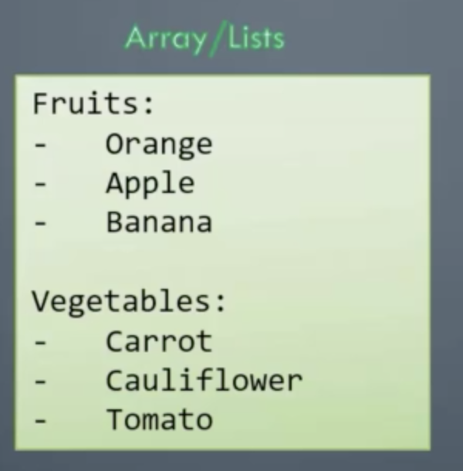

* **Maps/ Dictionaries**
  + We must have equal number of blank spaces

* **Lists containing Dictionaries example:**

**-Lists vs Dictionaries vs List of Dictionaries**

- When to use a dictionary?

- Store date of a single object.

**Multiple similar objects?**

* We use a list

* **List of dictionaries would look like this**

**Remark**

* Lists are ordered but dictionaries are not

